GLOVIA OM - SFRA Cartridge

***Version <19.1.0>***



**Table of Contents**

1. Summary 3

2. Component Overview 3

2.1 Functional Overview 3

2.2 Use Cases 3

2.3 Limitations, Constraints 3

2.4 Compatibility 3

2.5 Privacy, Payment 4

3. Implementation Guide 4

3.1 Setup 4

3.2 Configuration 4

3.2.1 Site Cartridge Path 4

3.2.2 Import Metadata 4

3.2.3 Service Framework Setup 4

3.2.4 Custom Site Preference 4

3.3 External Interfaces 5

3.4 Firewall Requirements 5

3.5 Testing 5

4. Operations, Maintenance 6

4.1 Data Storage 6

4.2 Availability 6

4.3 Support 6

5. User Guide 6

5.1 Roles, Responsibilities 6

5.2 Business Manager 6

5.3 Storefront Functionality 6

6. Known Issues 6

7. Release History 6

# 1. Summary

* *This GLOVIA OM API LINK Cartridge implements calls to the GLOVIA OM System to push order from Commerce Cloud. There is a Patch request callout also which updates the Order Number of GLOVIA OM back into Commerce Cloud. This integration implemented using Commerce Cloud API, which uses Salesforce as a Service Framework and allows access via Controller calls & hooks.*
* *GLOVIAOM cartridge designed and implemented to work with Salesforce Commerce Cloud version 19.5 and Storefront Reference Architecture (SFRA).*
* *This integration requires a contract with Fujitsu -GLOVIA OM System. For more information on contract terms and pricing contact* ***dremoquillo@fujitsu.com****.*
* *This integration includes:*
  + “int_gloviaom_sfra” cartridge
  + Instructions to setup the code
  + Instructions to configure the cartridges in Business Manager

# 2. Component Overview

## Functional Overview

This Cartridge enables the real-time sync of B2C commerce storefront orders to the GLOVIA OM system. GLOVIA OM system then processes the fulfillment of the Order and then updates the External Order number back to B2C commerce associated order.

This cartridge is design and implemented to work with Salesforce Commerce Cloud version 19.5 and Storefront Reference Architecture (SFRA).

## Use Cases

1. Upon placement of an order, there is a real-time callout from Salesforce Commerce Cloud to GLOVIA OM.
2. When user clicks “Update Order No” button from GLOVIA OM object record page, a Patch API callout will go from GLOVIA OM, which eventually updates an ExternalOrderNumber of Order into Salesforce Commerce Cloud using hook.

## Limitations, Constraints

* This integration does not support orders to multiple shipping addresses.
* This integration will not work for Guest Users, as we are allowing Order to placed, only from authenticated user, i.e., login from customer first, and then place the order.

## Compatibility

GLOVIAOM cartridge is design to work with Salesforce Commerce Cloud version 19.5 and Storefront Reference Architecture (SFRA).

## Privacy, Payment

NA

# 3. Implementation Guide

## Setup

Unzip the link release file, and import the following cartridges into your workspace:

* int_gloviaom_sfra

## Configuration

### Site Cartridge Path

* In Business Manager, navigate to Administration -> Sites -> Manage Sites
* In the Cartridges field, add the following to the start or before “app_storefront_base”:
  + int_gloviaom_sfra :
* Click Apply at the far right
* Click Apply

### Import Metadata

* In Business Manager, navigate to Administration -> Site Development -> Import & Export
* Under Import & Export Files, click Upload
* Click Choose File and navigate to the metadata folder in the downloaded cartridge, and select gloviaom_metadata.xml, click Upload
* Click Back button
* Under Meta Data, click on Import
* Select gloviaom_metadata.xml and click Next button on the right
* Once validation completes, click Import at far right again

### Service Framework Setup

* In Business Manager, navigate to Administration -> Operations -> Services –
  + Credentials Tab: Provide oAuth2 Connected App detail with credential of Salesforce Org
  + URL for Salesforce Production: https://login.salesforce.com/services/oauth2/token
  + URL for Salesforce Sandbox: https://test.salesforce.com/services/oauth2/token

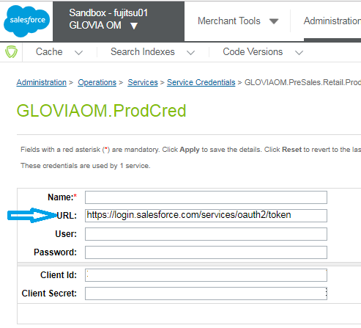

* + Profiles Tab: Setup Profile Information
  + Services Tab: Setup Service Information
    - The Service name needs to be update on Custom Site Preference as mentioned in below point.

### Custom Site Preference

* In Business Manager, navigate to Administration -> Merchant Tools -> Site Preference -> Custom Site Preference and provide Service Name which has been setup as per 3.2.3

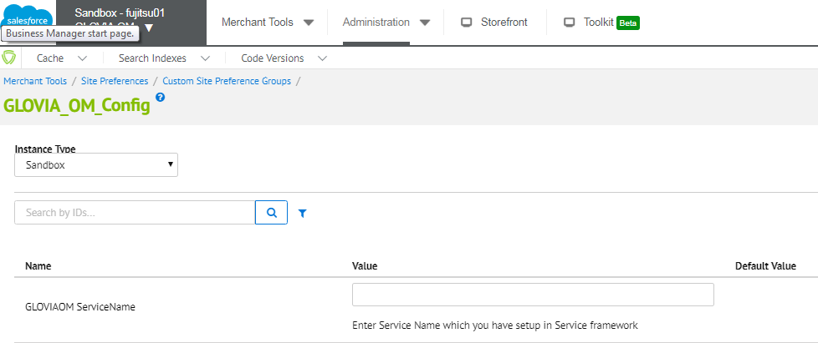

## External Interfaces

NA

## Firewall Requirements

The GLOVIA OM API service used by the order API listed on port 8081 for HTTPS traffic. These ports are not allowed by default for outbound connections from the Salesforce Commerce Cloud, so you will have to setup connected app and put the client id, secret etc information as per given in 3.2.3.

## Testing

*Access will be granted to GLOVIA OM staging instance, which will allow you to push orders from Salesforce Commerce Cloud. When testing the integration with a new instance of GLOVIA OM, the first step is to test placing orders into Commerce Cloud which will create order into GLOVIA OM. After placing order, you can find the order into staging of GLOVIA OM. You can write OCAPI into Salesforce by using Apex, and then you will need to use PATCH API of OCAPI to update the externalOrderNo back into Commerce Cloud. In PATCH Request, use following JSON in request body-*

*Request URL:*

https://<<INSTANCE_NAME>>.demandware.net/s/<<SITE_ID>>/dw/shop/v19_5/orders/<<COMMERCE_CLOUD_ORDERNO*>>*

*Request Body:*

*{*

*"c_externalOrderNo": "<<GLOVIAOM ORDER NUMBER>>"*

*}*

# 4. Operations, Maintenance

## Data Storage

No data is stored within Salesforce Commerce Cloud via custom objects or any other persistent storage mechanism.

## Availability

*The GLOVIA OM communication points are expected to be available at all times. The main connection point is via an API hosted by GLOVIA OM. If the order staging API is unavailable for some reason, then the customer will be unable to load their order. As a non-critical piece of the workflow, there is no fall back in this scenario. The customer either needs to try again, or can call into customer service to check their order status in this scenario.*

## Support

GLOVIA OM customer con contact their dedicated client services team for support.

# 5. User Guide

## Roles, Responsibilities

*During configuration of the cartridge, GLOVIA OM will provide a list of site preference values that will need to be enter to support the integration to OM.*

## Business Manager

None – no new business manager modules. Only site preferences needs to be updated.

## Storefront Functionality

No noticeable impact to the consumer. When an order in Commerce Cloud placed, it will routed to GLOVIA OM and consumer can look at the order detail into GLOVIA OM staging, which is created in real time – however, both of these are handled on the backend without the user being made aware.

# 6. Known Issues

None

# 7. Release History

|  |  |  |
| --- | --- | --- |
| **Version** | **Date** | **Changes** |
| 19.1.0 | 6/4/2019 | Initial release |